**Dental Management System**



Team Invictus

**Dhaval Pandya Yash Pandya**

**Prathamesh Verlekar Shivendra Shahi**

**Data Management and Database Design Professor Vincent Lattuada**

**Table of Contents:**

1.0 Introduction 3

2.0 Audience 4

3.0 High Level Diagram 6

4.0 Main Subject Areas 7

* 1. Business Rules 9
  2. In Scope Items 9
  3. Out of Scope Items 11

6.0 Entities and Attributes 12

7.0 Data Model 32

8.0 Definition and Abbreviation 36

# Revision History

|  |  |  |  |
| --- | --- | --- | --- |
| **Version** | **Changes Made** | **Date** | **Changed By** |
| 1.0 | Formatted the document and added  introduction. | 11/09/19 | Shivendra Shahi |
| 1.1 | Added Audiences and Business Rules | 11/10/19 | Prathamesh Verlekar |
| 1.2 | Added Main Subject Areas | 11/10/19 | Prathamesh Verlekar |
| 1.3 | Made few changes in Subject Areas | 11/11/19 | Shivendra Shahi |
| 2.0 | Added entities and attributes | 11/11/19 | Yash Pandya |
| 2.1 | Added Abbreviation and Definition | 11/11/19 | Yash Pandya |
| 3.0 | Added High Level Diagram | 11/12/19 | Dhaval Pandya |
| 3.1 | Added other cluster diagram and data model | 11/13/19 | Dhaval Pandya |
| 3.2 | Made changes in attributes tables | 11/13/19 | Shivendra Shahi |
| 3.3 | Added few more entities and attributes | 11/14/19 | Prathamesh Verlekar |
| 4.1 | Added new business rules | 11/14/19 | Yash Pandya |
| 4.2 | Made final changes in the data model | 11/14/19 | Dhaval Pandya |
| 5.1 | Made changes to dentist cluster | 11/27/19 | Prathamesh Verlekar |
| 5.2 | Made changes to treatment cluster | 11/28/19 | Dhaval Pandya |
| 5.3 | Made changes to inventory cluster | 11/28/19 | Shivendra Shahi |
| 5.4 | Made changes to Patient cluster | 11/29/19 | Yash Pandya |
| 6.1 | Added description to master tables | 11/30/19 | Shivendra Shahi |
| 6.2 | Added description to transaction tables | 11/30/19 | Yash Pandya |
| 7.1 | Made changes to all the tables and finalized it | 12/1/19 | Prathamesh Verlekar |
| 7.2 | Changed High level diagram as per requirements | 12/2/19 | Dhaval Pandya |

# 1.0 Introduction:

Dental Management System is a database management system for monitoring and handling the appointments and other related activities in a Dental Office. The design of the model will be done using TOAD Data Modeler and implementation will be done using Microsoft SQL Server. The system will also store the details regarding the invoices generated, insurances used by the patient, patient treatment history and other high-level operations.

Dental Office is an organization that is responsible for providing a health medication and treatment for all types of dental patients. The traditional method means the customers need to fill in their details in the registration form manually and the information will only be kept in files. After the registration, the files will be placed in the rack and this will cause problems like taking a long time to retrieve the information, make mistakes while writing or misplacing the files.

Dental Management System is specially designed to let the staff have high- efficiency management tools, computerized and systematic patient records, and detail of treatment records. This system also provides an appointment feature, which allows staff to view the appointment that already made by the dentist/patient. Receptionist/Dentist can track all future appointments. The patient treatment module consists of the information about the tooth examination and record and list of treatment that has done. Apart from that, dental treatment and disease modules provide information about the cause of tooth extraction and tooth filling.

The proposed system will save the effort and the time of patients from waiting to make the appointment as well as reduce the work of system administrators to access information for the report and easier to manage the appointment. The system administrator needs to maintain the records of patients. Patients should be able to know the availability of a date.

* 1. **Audiences**

**Admin**

* + - The role of the admin will be to enter and manage the system. He will be responsible for updating the data like if appointment is cancelled then change the status to cancel, if it is done then change the status to complete or done.
    - All the database activities will e managed by the admin. Admin will be allowed to create new roles if required. He can increase or decrease the security of a table.
    - Admin will play a main role in managing the system from data entry to data deletion and updating the data as per the requirement.

**Dentist**

* + - Apartment from admin, dentist will also be allowed to access the system.
    - He/ She can check their appointments scheduled for a given date.
    - He/ She can access the patient history and medical details with the help of the system. This will help the dentist to know more about the patient history before starting the treatment. He will get the details of the necessary precaution which needs to be taken before starting the treatment
    - Dentist can also give prescription through the system directly to the patient without an appointment.
    - He/ She will be informed about the license expiry, so that the Dentist can renew or make a new license.

# 3.0 High Level Diagram

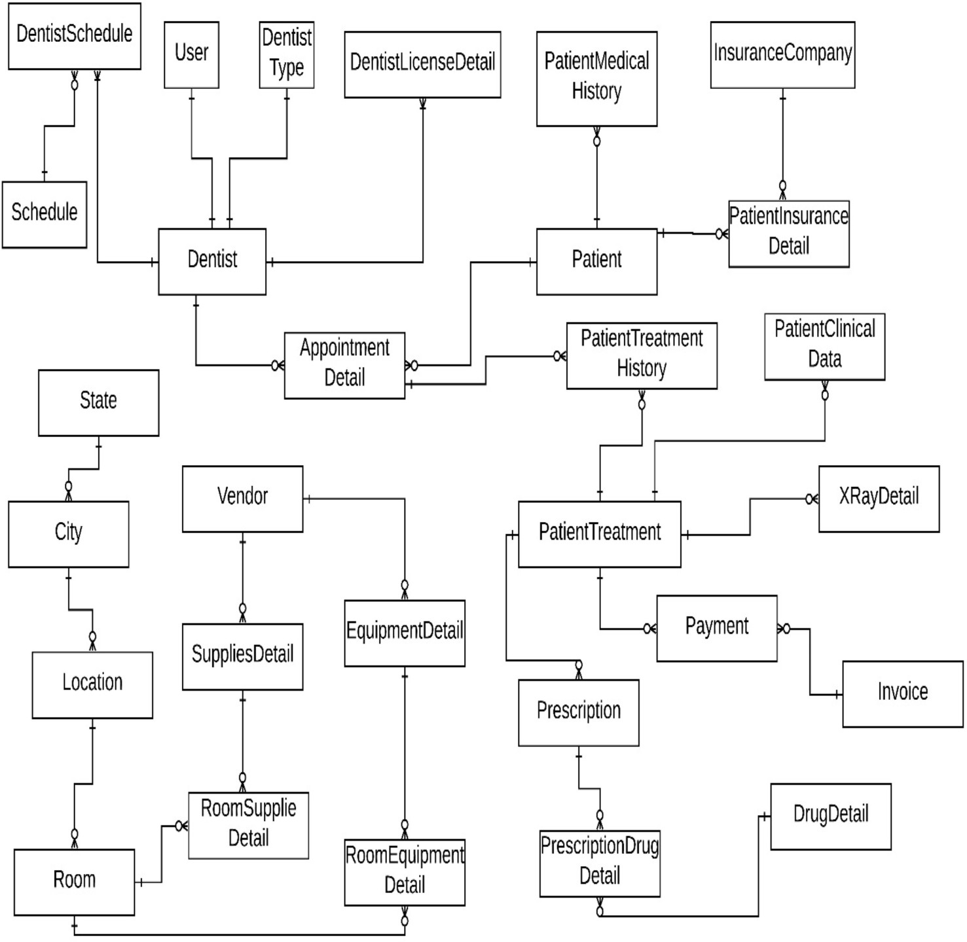

# Main Subject Areas

**Patient**

* + - The Patient entity cluster will store all the information related to the patient identity like Patient ID, Patient Name, Address, Phone Number, E-Mail ID along with insurance details and medical history. This entity cluster will help in capturing all the information related to patient. Patient entity cluster will have a relationship with the dentist entity cluster with the help of appointment.

**Provider**

* + - The Provider entity cluster will store all the information about the dentist who will be operating on a patient. It will have information about the License a provider is having, years of experience, Provider ID, Provider name, etc. It will also store the insurance details and the appointment details. It will have a relationship with the appointment entity cluster as well as treatment entity cluster.

**Visit**

* + - This will have the details regarding the treatment which has been given to the patient during the current visit. It will also have details regarding any treatment taken from previous visits. Details regarding prescription given will also be stored in this entity cluster. Invoice will be generated based on the treatment given to the patient.

**Inventory**

* + - Inventory management will track the detail of all the supplies and equipment. It will track the cost and availability of all the Equipment and supplies. It will also record the contract details with a vendor such as a purchase contract or maintenance contract. Apart from this, the user can easily track the detail of any equipment such as where it is located, is it functioning properly or not, etc.

# Business Rules

# In Scope Items

|  |  |  |
| --- | --- | --- |
| **ID** | **Business Rules** | **Area** |
| IS01 | The dentist will provide the treatment to one/many patients. | Dentist |
| IS02 | Dentist will provide the medical prescription to the patient | Dentist |
| IS03 | Dentist can treat a single patient at a time. | Dentist |
| IS04 | The Dentist Entity will store basic Information of Dentist such as Name, Phone Number, Address etc. | Dentist |
| IS05 | The Dentist can provide service to multiple location. | Dentist |
| IS06 | Every Dentist must have a valid license. | Dentist |
| IS07 | The Dentist can have one or multiple License according their specialization. | Dentist |
| IS08 | The Detail of license will be stored in License Detail Entity such as License Number, status, Type etc. | Dentist |
| IS09 | Confidential data such as SSN, Tax Payer Id, etc. should be stored in separate reference table with more security applied to the table. | Dentist |
| IS10 | The Specialization Entity will store the information of the doctor and detail of his/her specialization such as Dentist can be general dentist, orthodontist, prosthodontist etc. | Dentist |
| IS11 | Appointments booked by every patient will be recorded along with date, time and  Dentist's details with whom the appointment is booked. | Dentist |
| IS12 | The patient Entity will store the basic detail of patient such as Name, Phone Number, and Emergency Number. | Patient |
| IS13 | Other Patient Details like missing teeth, facial growth problems, oral habit, spaced teeth etc. must be recorded in Patient’s health history. | Patient |
| IS14 | A patient can have more than one insurance. | Patient |
| IS15 | There cannot be multiple appointments at a single time for a patient. | Patient |
| IS16 | The system will store the details of various dental disease details. | Patient |
| IS17 | The system will store the detail of the treatment given by dentist to the patient. | Patient |
| IS18 | Patient can pay the bill via different payment mode and can set the preferred payment mode. | Patient |
| IS19 | The dentist can prescribe the drugs to the patient according to the disease. | Prescription |
| IS20 | The patient can get prescriptions from multiple dentists. | Prescription |
| IS21 | The Patient can change the payment mode and set the primary payment mode | Invoice |
| IS22 | The system will save the demographic information of the patient such as Address. | Patient |
| IS23 | A Patient can have one or more home addresses. | Patient |
| IS24 | Patient will have Emergency Contact Details | Patient |
| IS25 | Details regarding number of upper teeth and number of lower teeth of the patient must be recorded. | Patient |
| IS26 | Patient history must contain previous medical history. | Patient |
| IS27 | Multiple appointments can be made by a patient at multiple locations with different time | Appointment |

|  |  |  |
| --- | --- | --- |
| IS28 | There is appointment status which will maintain the status of appointment such as Done, Cancelled etc. | Appointment |
| IS29 | An appointment must be associated with a specific location via a room | Appointment |
| IS30 | A room can be booked more than one time for different appointments. | Location |
| IS31 | Prescription provider name must be included in the prescription. | Prescription |
| IS32 | Treatment must have a treatment ID that can be used for invoice and dentist. | Treatment |
| IS33 | Details regarding which tooth has been treated during the treatment must be recorded. | Treatment |
| IS34 | The Dentist can send the prescription to the patient without having any appointment. | Prescription |
| IS35 | There is at least one invoice against the appointment | Invoice |
| IS36 | The Dentist can work with multiple schedule at multiple location | Dentist |
| IS37 | The Dentist can have one or more than one appointment in his/her working hours | Dentist |
| IS38 | The System will track the all the Equipment Details such as vendor detail, Is the equipment portable etc. | Equipment |
| IS39 | The Vendor Detail will save the all the information of Equipment / Supplies vendor | Vendor |
| IS40 | The System will track the information of all the available supplies | Supplies |
| IS41 | Supplies must contain supplier ID to track the shipment. | Supplies |
| IS42 | The System will track the contract details with Multiple vendors of equipment and supplies | Equipment |
| IS43 | We will track the details of the equipment such as where it is located currently | Equipment |
| IS44 | Medical equipment can be bought from multiple vendors. | Vendor |
| IS45 | Warranty details of equipment should be stored for repairing and replacement. | Equipment |

# Out of Scope Items

|  |  |  |
| --- | --- | --- |
| **ID** | **Business Rules** | **Area** |
| OS01 | Feedback for dentist is not tracked. | Dentist |
| OS02 | Salaries of dentist and staff are not tracked in the system | Dentist |
| OS03 | Schedule of staff working in the office is not captured. | Other Staff |
| OS04 | Other staff working in office but not participating in the dental care of the patient are not tracked. | Other Staff |
| OS05 | Cost of the prescribed medicines are not tracked in the system. | Medicine |
| OS06 | Utilities that are being used in the room are not tracked. | Location |
| OS07 | Finances of Dentist office are not tracked. | Dentist |
| OS08 | Medicines for other diseases apart from dental problems, | Medicine |
| OS09 | No method for membership plans/discounts to the regular patients at this dental office. | Membership |
| OS10 | Status of prescription is not required. | Prescription |

# Entities and Attributes

**1.0 Master Tables**

## City Table

This entity contains the details of the city in which the clinic is, this is a part of the address. It contains City name, city code and the state code where the city is.

|  |  |  |  |
| --- | --- | --- | --- |
| **Attribute_ID** | **DataType** | **Constraints** | **Definition with example** |
| City_ID | Char (2) | Primary Key (PK),  Not Null (NN) | A City code to differentiate Different Cities in a table. Example. 01,02 |
| City_Name | Varchar (50) | Not Null (NN) | Name of the city. For example, Boston, New York. |
| State_Code | Char (2) | Foreign Key, Not Null (NN) |  |
| Created_By | Integer | Not Null (NN) | The data created by example 1,2,3 |
| Created_Time | DateTime | Not Null (NN) | The data created time example 12/10/2019 12:00:00 |
| Modified_By | Integer | Not Null (NN) | The data modified by example 4,5,6 |
| Modified_Time | DateTime | Not Null (NN) | The data modified time example 12/11/2019 13:10:00 |

## State Table

This entity contains the details of the state where the clinic is, this is a part of the address. It contains the state code and state name.

|  |  |  |  |
| --- | --- | --- | --- |
| **Attribute_ID** | **DataType** | **Constraints** | **Definition with example** |
| State_Code | Char (2) | Primary Key (PK), (NN) | A State code to differentiate Different State in a table. Example. 01,02 |
| State_Name | Varchar (50) | Not Null (NN) | Name of the State. For example, Texas, Massachusetts. |
| Created_By | Integer | Not Null (NN) | The data created by example 1,2,3 |
| Created_Time | DateTime | Not Null | The data created time example 12/10/2019 12:00:00 |
| Modified_By | Integer | Not Null (NN) | The data modified by example 4,5,6 |
| Modified_Time | DateTime | Not Null (NN) | The data modified time example 12/11/2019 13:10:00 |

## Insurance Company

This entity will store the company details of the insurance so that if a patient is using more than one insurance, we can have a record of the amount of bill covered by a different insurance company and the treatments which are included in different insurance. Different companies will have different policies, terms, and conditions to use the insurance. This entity will record all these details.

|  |  |  |  |
| --- | --- | --- | --- |
| **Attribute_ID** | **DataType** | **Constraints** | **Definition with example** |
| Insurance_ Company_ID | Integer | Primary Key (PK),  Not Null (NN) | A State code to differentiate Different State in a table. Example. 01,02 |
| State_Name | Varchar (50) | Not Null (NN) | Name of the State. For example, Texas, Massachusetts. |
| Created_By | Integer | Not Null (NN) | The data created by example 1,2,3 |
| Created_Time | DateTime | Not Null  (NN) | The data created time example 12/10/2019 12:00:00 |
| Modified_By | Integer | Not Null (NN) | The data modified by example 4,5,6 |
| Modified_Time | DateTime | Not Null (NN) | The data modified time example 12/11/2019 13:10:00 |

## Tooth

This entity contains the Tooth_Id which uniquely identifies every tooth. It also contains tooth description and an attribute called Tooth_File_Path which contains the image path of a tooth.

|  |  |  |  |
| --- | --- | --- | --- |
| **Attribute_ID** | **DataType** | **Constraints** | **Definition with example** |
| Tooth_ID | Integer | Primary Key (PK),  Not Null (NN) | A unique Id to differentiate between different tooth. Example 1,2,3 |
| Tooth_ Description | Varchar (200) | Not Null (NN) | Description about tooth. Example canine tooth |
| Tooth_File_ Path | Varchar (200) | Not Null (NN) | Tooth file path contains the image path of a tooth. |
| Created_By | Integer | Not Null | The data created by, example 1,2,3 |
| Created_Time | DateTime | Not Null (NN) | The data created time example 12/10/2019 12:00:00 |
| Modified_By | Integer | Not Null  (NN) | The data modified by example 4,5,6 |
| Modified_Time | DateTime | Not Null (NN) | The data modified time example 12/11/2019 13:10:00 |

## Location

This entity will have details regarding the different locations where the dental office is present, along with the room details and address of the dental office. It will be linked to the appointment entity in order to have these details in the appointment history.

|  |  |  |  |  |
| --- | --- | --- | --- | --- |
| **Attribute_ID** | **DataType** | **Constraints** | | **Definition with example** |
| Location_ID | Integer | Primary Key (PK),  Not Null (NN) | | A unique Id to differentiate between different Location. Example 1,2,3 |
| Location_ Name | Varchar (100) | Not (NN) | Null | Name of a Location. Example Washington Street |
| Location_ Address | Varchar (200) | Not (NN) | Null | Location address. Example 115 Northampton Street |
| State_Code | Integer | Foreign Key (FK), Not  Null (NN) | |  |
| City_ID | Integer | Foreign Key (FK), Not  Null (NN) | |  |
| Zip_Code | Integer | Not (NN) | Null | Zip code of a location. Example, 02118 |
| Created_By | Integer | Not  (NN) | Null | The data created by, example 1,2,3 |
| Created_Time | DateTime | Not (NN) | Null | The data created time example 12/10/2019 12:00:00 |
| Modified_By | Integer | Not (NN) | Null | The data modified by example 4,5,6 |
| Modified_Time | DateTime | Not  (NN) | Null | The data modified time example 12/11/2019 13:10:00 |

## Room

This entity will have details regarding the different types of rooms and their names, along with the Room_Id. It will be linked to the appointment entity in order to have these details in the appointment history. Every Patient will be assigned a room to be treated during the visit.

|  |  |  |  |
| --- | --- | --- | --- |
| **Attribute_ID** | **DataType** | **Constraints** | **Definition with example** |
| Room_ID | Integer | Primary Key (PK),  Not Null (NN) | A unique Id to differentiate between different Room. Example 1,2,3 |
| Room_Name | Varchar (50) | Null (N) | Name of a Room. Example Tulip |
| Location_ID | Integer | Foreign Key (FK), Not  Null (NN) |  |
| Room_Number | Integer | Not Null (NN) | Number of a room. Example 202 |
| Floor | Small Integer | Not Null (NN) | Floor number. Example First, Second Floor |
| Created_By | Integer | Not Null  (NN) | The data created by, example 1,2,3 |
| Created_Time | DateTime | Not Null (NN) | The data created time example 12/10/2019 12:00:00 |
| Modified_By | Integer | Not Null (NN) | The data modified by example 4,5,6 |
| Modified_Time | DateTime | Not Null  (NN) | The data modified time example 12/11/2019 13:10:00 |

## Vendor

This entity contains the detail about the various vendors who provides supplies and equipments. Vendor_Id is used to uniquely identify different vendors associated.

|  |  |  |  |
| --- | --- | --- | --- |
| **Attribute_ID** | **DataType** | **Constraints** | **Definition with example** |
| Vendor_ID | Integer | Primary Key (PK),  Not Null (NN) | A unique Id to differentiate between different Vendors. Example 1,2,3 |
| Vendor_Name | Varchar (50) | Not Null (NN) | Name of the Vendor. For example, Afrojack. |
| Created_By | Integer | Not Null | The data created by example 1,2,3 |
| Created_Time | DateTime | Not Null | The data created time example 12/10/2019 12:00:00 |
| Modified_By | Integer | Not Null (NN) | The data modified by example 4,5,6 |
| Modified_Time | DateTime | Not Null (NN) | The data modified time example 12/11/2019 13:10:00 |

## Drug Details

This entity contains the description about the all the Drugs that a Dentist would be prescribing to a Patient. It contains Drug name, Drug type and Drug Description. The Drug_Detail_Id will uniquely identify all the drugs.

|  |  |  |  |
| --- | --- | --- | --- |
| **Attribute_ID** | **DataType** | **Constraints** | **Definition with example** |
| Drug_detail_ID | Integer | Primary Key (PK),  Not Null (NN) | A unique Id to differentiate between different Drug Details. Example 1,2,3 |
| Drug_Name | Varchar (50) | Not Null (NN) | Name of the Drug. For example, Paracetamol. |
| Drug_type | Varchar (10) | Not Null (NN) | Type of Drug. Example High Dose |
| Drug_  Description | Varchar  (200) | Not Null  (NN) | Description about Drugs. Example Paracetamol is for cold  and cough. |
| Created_By | Integer | Not Null (NN) | The data created by example 1,2,3 |
| Created_Time | DateTime | Not Null (NN) | The data created time example 12/10/2019 12:00:00 |
| Modified_By | Integer | Not Null  (NN) | The data modified by example 4,5,6 |
| Modified_Time | DateTime | Not Null (NN) | The data modified time example 12/11/2019 13:10:00 |

# 2.0 Transaction tables

## Dentist

The Dentist Entity will store the details about all the dentists working in the dental office who will be operating on a patient. This will have details like Dentist’s name, SSN, Phone number and years of experience he has. It will have Dentist_Id as primary key for uniquely identifying different dentists.

|  |  |  |  |  |
| --- | --- | --- | --- | --- |
| **Attribute_ID** | **DataType** | **Constraints** | | **Definition with example** |
| Dentist_ID | Integer | Primary Key (PK),  Not Null (NN) | | A unique Id to differentiate between different Dentist. Example 1,2,3 |
| First_Name | Varchar (50) | Not (NN) | Null | First Name of the Dentist. For example, Jack. |
| Middle_Name | Varchar  (50) | Null (N) | | Middle Name of the dentist. For example, J. |
| Last_Name | Varchar (50) | Not (NN) | Null | Last Name of the dentist. For Example, Ryan. |
| Dentist_SSN | Varchar (10) | Not (NN) | Null | SSN number of a dentist. Example, 1QAW23S34 |
| Dentist_  Gender | Varchar  (5) | Not  (NN) | Null | Gender of a dentist. Example, Male |
| Dentist_Phone | Varchar (10) | Not (NN) | Null | Phone number of dentists. Example, 8578005124 |
| Dentist_Type  _ID | Integer | Foreign Key (FK), Not  Null (NN) | |  |
| User_ID | Integer | Foreign Key (FK), Not  Null | |  |
| Dentist_Work  _Experience | Integer | Not (NN) | Null | Work experience of a Dentist. Example 2 |
| Created_By | Integer | Not (NN) | Null | The data created by example 1,2,3 |
| Created_Time | DateTime | Not (NN) | Null | The data created time example 12/10/2019 12:00:00 |
| Modified_By | Integer | Not  (NN) | Null | The data modified by example 4,5,6 |
| Modified_Time | DateTime | Not (NN) | Null | The data modified time example 12/11/2019 13:10:00 |

## Dentist Type

This entity will describe about the type of dentist. For example, there are different types of Dentistry practices like Periodontology, Orthodontics, Prosthodontics, Endodontics etc. This entity will provide details about the type of Dentist.

|  |  |  |  |
| --- | --- | --- | --- |
| **Attribute_ID** | **DataType** | **Constraints** | **Definition with example** |
| Dentist_type_ ID | Integer | Primary Key (PK),  Not Null (NN) | A unique Id to differentiate between different Dentist Type. Example 1,2,3 |
| Name | Varchar (50) | Not Null (NN) | Name of Dentist Type. Example Ortho surgeon |
| Description | Varchar (200) | Not Null (NN) | Description About Dentist Type. Example, Ortho surgeon is for maintaining the care for teeth. |
| Created_By | Integer | Not Null | The data created by, example 1,2,3 |
| Created_Time | DateTime | Not Null | The data created time example 12/10/2019 12:00:00 |
| Modified_By | Integer | Not Null | The data modified by example 4,5,6 |
| Modified_Time | DateTime | Not Null (NN) | The data modified time example 12/11/2019 13:10:00 |

## Dentist License Details

This entity will contain the information about the License details of all the Dentists along with details like License Expiry date.

|  |  |  |  |
| --- | --- | --- | --- |
| **Attribute_ID** | **DataType** | **Constraints** | **Definition with example** |
| Dentist_License Detail_ID | Integer | Primary Key (PK),  Not Null (NN) | A unique Id to differentiate between different Dentist. Example 1,2,3 |
| Dentist_ID | Integer | Foreign Key (FK)Not  Null (NN) |  |
| LicenseNumber | Integer | Foreign Key (FK), Not  Null (NN) |  |
| License_Expire  _Date | DateTime | Null (N) | License Expire Date. Example, 12/10/2019 |
| Created_By | Integer | Not Null (NN) | The data created by, example 1,2,3 |
| Created_Time | DateTime | Not Null (NN) | The data created time example 12/10/2019 12:00:00 |
| Modified_By | Integer | Not Null  (NN) | The data modified by example 4,5,6 |
| Modified_Time | DateTime | Not Null (NN) | The data modified time example 12/11/2019 13:10:00 |

## Schedule

This will contain the details about the Schedule such as Start time and End time. The different Schedule_Id will differentiate between different schedule.

|  |  |  |  |
| --- | --- | --- | --- |
| **Attribute_ID** | **DataType** | **Constraints** | **Definition with example** |
| Schedule_ID | Integer | Primary Key (PK),  Not Null (NN) | A unique Id to differentiate between different Schedule. Example 1,2,3 |
| Start_Time | DateTime | Not Null (NN) | Schedule Starting Time. Example 12/10/201912:10:00 |
| End_Time | DateTime | Not Null (NN) | Schedule ending time. Example, 12/23/2019 13:00:09 |
| Created_By | Integer | Not Null  (NN) | The data created by, example 1,2,3 |
| Created_Time | DateTime | Not Null (NN) | The data created time example 12/10/2019 12:00:00 |
| Modified_By | Integer | Not Null (NN) | The data modified by example 4,5,6 |
| Modified_Time | DateTime | Not Null (NN) | The data modified time example 12/11/2019 13:10:00 |

## Dentist schedule Table

This entity will contain detail about different schedule that a Dentist would have.

|  |  |  |  |
| --- | --- | --- | --- |
| **Attribute_ID** | **DataType** | **Constraints** | **Definition with example** |
| Dentist_Schedule  _ID | Integer | Primary Key (PK),  Not Null (NN) | A unique Id to differentiate between different Dentist schedule. Example 1,2,3 |
| Dentist_ID | Integer | Foreign Key (FK)Not  Null (NN) |  |
| Schedule_ID | Integer | Foreign Key (FK)Not  Null (NN) |  |
| Day | Varchar (10) | Not Null (NN) | This will give the particular day for dentist schedule. |
| Created_By | Integer | Not Null (NN) | The data created by, example 1,2,3 |
| Created_Time | DateTime | Not Null  (NN) | The data created time example 12/10/2019 12:00:00 |
| Modified_By | Integer | Not Null (NN) | The data modified by example 4,5,6 |
| Modified_Time | DateTime | Not Null (NN) | The data modified time example 12/11/2019 13:10:00 |

## Patient

The Patient entity will store all the information related to the patient identity like Patient Id, Patient Name, Age, Address, Phone Number, E-Mail ID and Emergency contact details. It will have Patient_Id to uniquely identify every patient visiting the dental office. Patient entity cluster will have a relationship with the Dentist cluster with the help of appointment.

|  |  |  |  |  |
| --- | --- | --- | --- | --- |
| **Attribute_ID** | **DataType** | **Constraints** | | **Definition with example** |
| Patient_ID | Integer | Primary Key (PK),  Not Null (NN) | | A unique Id to differentiate between different Patient. Example 1,2,3 |
| First_Name | Varchar (50) | Not (NN) | Null | First Name of the Patient. For example, Jack. |
| Middle_Name | Varchar (50) | Null (N) | | Middle Name of the Patient. For example, J. |
| Last_Name | Varchar  (50) | Not  (NN) | Null | Last Name of the Patient. For Example, Ryan. |
| Date_Of_Birth | Integer | Not (NN) | Null | Date of Birth of a patient. Example, 12/10/2019 |
| Patient_ Address | Varchar (5) | Not (NN) | Null | Address of a patient. For Example, 115 Northampton Street. |
| State_Code | Integer | Foreign Key (FK), Not  Null (NN) | |  |
| City_Code | Integer | Foreign Key (FK), Not  Null (NN) | |  |
| Zip_Code | Integer | Not (NN) | Null | Zip code of patient. Example, 02118 |
| Patient_ Emergency_ Contact_ Number | Varchar (10) | Not Null (NN) | | Emergency contact number of a patient. Example, 8578444512 |
| Patient_ Emergency  _Contact_ Name | Varchar (50) | Not Null (NN) | | Emergency contact name of a patient. Example, Yash |
| Patient_Age | Integer | Not Null  (NN) | | Calculated Field through Date of Birth. Example, 23 |
| Created_By | Integer | Not (NN) | Null | The data created by example 1,2,3 |
| Created_Time | DateTime | Not (NN) | Null | The data created time example 12/10/2019 12:00:00 |
| Modified_By | Integer | Not  (NN) | Null | The data modified by example 4,5,6 |
| Modified_Time | DateTime | Not (NN) | Null | The data modified time example 12/11/2019 13:10:00 |

## Patient Medical History

This entity will have a patient history as if the patient is allergic to things such as latex, anesthetic, etc. It will also have the smoking history of the patient and will have details about any previous medication or treatment which the patient has taken from the same dentist or from any others. These details will help the dentist to take precautions during the treatment.

|  |  |  |  |
| --- | --- | --- | --- |
| **Attribute_ID** | **DataType** | **Constraints** | **Definition with example** |
| Patient_ Medical_History  _ID | Integer | Primary Key (PK),  Not Null (NN) | A unique Id to differentiate between different Patient medical history. Example 1,2,3 |
| Patient_ID | Integer | Foreign Key (FK)Not  Null (NN) |  |
| Patient_ Allregry_Details | Varchar (250) | Not Null (NN) | Allergy Details of a patient. Example itching in skin. |
| Other_Diseases | Varchar (250) | Not Null (NN) | Other diseases that patient has. Example cough cold |
| Patient_Medical  _Report_File  _Path | Varchar (200) | Not Null (NN) | Location where medical report of a patient is kept. |
| Created_By | Integer | Not Null (NN) | The data created by, example 1,2,3 |
| Created_Time | DateTime | Not Null (NN) | The data created time example 12/10/2019 12:00:00 |
| Modified_By | Integer | Not Null  (NN) | The data modified by example 4,5,6 |
| Modified_Time | DateTime | Not Null (NN) | The data modified time example 12/11/2019 13:10:00 |

## Patient Insurance Details

This entity will store insurance details like type of insurance, amount or percentage of the bill it covers, which all treatments are included, etc. A single patient can use more than one insurance for his treatment so all those insurances should be linked with the patient while billing.

|  |  |  |  |
| --- | --- | --- | --- |
| **Attribute_ID** | **DataType** | **Constraints** | **Definition with example** |
| Patient_ Insurance_ Details_ID | Integer | Primary Key (PK),  Not Null (NN) | A unique Id to differentiate between different Patient Insurance details. Example 1,2,3 |
| Patient_ID | Integer | Foreign Key (FK)Not  Null (NN) |  |
| Insurance_ Number | Integer | Not Null (NN) | Patient health Insurance number. Example 642318 |
| Insurance_ Cover_Amount | Money | Not Null (NN) | Patient insurance cover amount. Example $23456 |
| Insurance_ Company_ID | Integer | Foreign Key (FK), Not  Null (NN) |  |
| Created_By | Integer | Not Null (NN) | The data created by, example 1,2,3 |
| Created_Time | DateTime | Not Null  (NN) | The data created time example 12/10/2019 12:00:00 |
| Modified_By | Integer | Not Null (NN) | The data modified by example 4,5,6 |
| Modified_Time | DateTime | Not Null (NN) | The data modified time example 12/11/2019 13:10:00 |

## Equipment Details

This will give information about all the equipment that are used for the dental treatment of the Patient like X-ray machines, dental chairs, etc. It will be linked to a room or a location.

|  |  |  |  |  |
| --- | --- | --- | --- | --- |
| **Attribute_ID** | **DataType** | **Constraints** | | **Definition with example** |
| Equipment_ Detail_ID | Integer | Primary Key (PK),  Not Null (NN) | | A unique Id to differentiate between different Equipment Details. Example 1,2,3 |
| Equipment_ Name | Varchar (100) | Not (NN) | Null | Name of the equipment. Example Forceps |
| Equipment_ Type | Varchar (10) | Not (NN) | Null | Type of Equipment Used. Example ting |
| Is_Portable | Boolean | Not  (NN) | Null | Can Equipment be moved from place to place? Example  Yes |
| Vendor_ID | Integer | Foreign Key (FK), Not  Null (NN) | |  |
| Contract_End Date | DateTime | Not Null (NN) | | Date at which contract ends. Example 12/10/2019 |
| Equipement_  Total_Quantity | Integer | Not Null  (NN) | | Total Quantity of Equipment. Example 20 |
| Equipment_ Description | Varchar (200) | Not Null (NN) | | Description of equipment. Example It is used for treatment. |
| Created_By | Integer | Not (NN) | Null | The data created by, example 1,2,3 |
| Created_Time | DateTime | Not  (NN) | Null | The data created time example 12/10/2019 12:00:00 |
| Modified_By | Integer | Not (NN) | Null | The data modified by example 4,5,6 |
| Modified_Time | DateTime | Not (NN) | Null | The data modified time example 12/11/2019 13:10:00 |

## Room Equipment Details

This entity will have details about the equipment that would be used in the respective room. This will contain equipment detail id, room id and equipment quantity.

|  |  |  |  |
| --- | --- | --- | --- |
| **Attribute_ID** | **DataType** | **Constraints** | **Definition with example** |
| Room_ Equipment  _Details_ID | Integer | Primary Key (PK),  Not Null (NN) | A unique Id to differentiate between different Room equipment details. Example 1,2,3 |
| Room_ID | Integer | Foreign Key (FK)Not  Null (NN) |  |
| Equipment_ Detail_ID | Integer | Foreign Key (FK)Not  Null (NN) |  |
| Quantity | Integer | Not Null | Number of equipment used. Example 24 |
| Created_By | Integer | Not Null | The data created by, example 1,2,3 |
| Created_Time | DateTime | Not Null | The data created time example 12/10/2019 12:00:00 |
| Modified_By | Integer | Not Null | The data modified by example 4,5,6 |
| Modified_Time | DateTime | Not Null | The data modified time example 12/11/2019 13:10:00 |

## Supplies Details

This will have details of all the types of supplies which are being used during the treatment and which are going to be charged to the Patient. It will also store the details of the quantity of medicine and other supplies which are used or need to be refilled.

|  |  |  |  |  |
| --- | --- | --- | --- | --- |
| **Attribute_ID** | **DataType** | **Constraints** | | **Definition with example** |
| Supplies  _Details_ID | Integer | Primary Key (PK),  Not Null (NN) | | A unique Id to differentiate between different Supplies details. Example 1,2,3 |
| Supplies_Name | Varchar (50) | Not (NN) | Null | Name of the supplies. |
| Supplies_  Description | Varchar  (200) | Not  (NN) | Null | Description about supplies. |
| TotalQuantity | Integer | Not (NN) | Null | Number of Supplies used. Example 24 |
| Vendor_ID | Integer | Foreign Key (FK), Not  Null (NN) | |  |
| Created_By | Integer | Not Null | | The data created by, example 1,2,3 |
| Created_Time | DateTime | Not Null | | The data created time example 12/10/2019 12:00:00 |
| Modified_By | Integer | Not Null | | The data modified by example 4,5,6 |
| Modified_Time | DateTime | Not Null | | The data modified time example 12/11/2019 13:10:00 |

## Room Supplies Details

This entity will contain the detail about the supplies and quantity of supplies that would be used in a room.

|  |  |  |  |
| --- | --- | --- | --- |
| **Attribute_ID** | **DataType** | **Constraints** | **Definition with example** |
| Room_ Supplies Details_ID | Integer | Primary Key (PK),  Not Null (NN) | A unique Id to differentiate between different Room Supplies details. Example 1,2,3 |
| Room_ID | Integer | Foreign Key (FK)Not  Null (NN) |  |
| Equipment_ Detail_ID | Integer | Foreign Key (FK)Not  Null (NN) |  |
| Quantity | Integer | Not Null | Number of Quantity used. Example 24 |
| Created_By | Integer | Not Null | The data created by, example 1,2,3 |
| Created_Time | DateTime | Not Null | The data created time example 12/10/2019 12:00:00 |
| Modified_By | Integer | Not Null | The data modified by example 4,5,6 |
| Modified_Time | DateTime | Not Null | The data modified time example 12/11/2019 13:10:00 |

## Appointment Detail

This entity will store all the details related to the appointments made by every patient with the dentist. It will have details regarding the Patient as well as the Dentist assigned to treat the patient.

|  |  |  |  |
| --- | --- | --- | --- |
| **Attribute_ID** | **DataType** | **Constraints** | **Definition with example** |
| AppointmentDetail  _ID | Integer | Primary Key (PK),  Not Null (NN) | A unique Id to differentiate between different appointment. Example 1,2,3 |
| Dentist_ID | Integer | Foreign Key (FK), Not  Null (NN) |  |
| Patient_ID | Integer | Foreign Key (FK), Not  Null (NN) |  |
| Room_ID | Integer | Foreign Key (FK), Not  Null (NN) |  |
| Start_Time | Date Time | Not Null (NN) | Appointment Start time. Example 12/10/2019 12:20:00 |
| End_Time | Date Time | Not Null | Appointment End time. Example 12/11/2019 13:25:00 |
| Created_By | Integer | Not Null | The data created by, example 1,2,3 |
| Created_Time | DateTime | Not Null | The data created time example 12/10/2019 12:00:00 |
| Modified_By | Integer | Not Null | The data modified by example 4,5,6 |
| Modified_Time | DateTime | Not Null | The data modified time example 12/11/2019 13:10:00 |

## Patient Treatment

This will have the details regarding the treatment which has been given to the patient during the current visit. It will also have details regarding any treatment taken from the catalog to reduce the billing time.

|  |  |  |  |  |
| --- | --- | --- | --- | --- |
| **Attribute_ID** | **DataType** | **Constraints** | | **Definition with example** |
| Patient_ Treatment_ID | Integer | Primary Key (PK),  Not Null (NN) | | A unique Id to differentiate between different Patient Treatment. Example 1,2,3 |
| Appointment  _Details_ID | Integer | Foreign Key (FK), Not  Null (NN) | |  |
| Treatment_ Comment | Varchar (500) | Not Null (NN) | | Comment about treatment. |
| Created_By | Integer | Not (NN) | Null | The data created by, example 1,2,3 |
| Created_Time | DateTime | Not  (NN) | Null | The data created time example 12/10/2019 12:00:00 |
| Modified_By | Integer | Not (NN) | Null | The data modified by example 4,5,6 |
| Modified_Time | DateTime | Not (NN) | Null | The data modified time example 12/11/2019 13:10:00 |

## X-ray Details

This entity will contain the details about the X-ray of tooth of each patient if needed. It will store the treatment Id, Patient Id and Tooth Id along with X-ray file path where X- rays are kept.

|  |  |  |  |
| --- | --- | --- | --- |
| **Attribute_ID** | **DataType** | **Constraints** | **Definition with example** |
| X-ray  _Details_ID | Integer | Primary Key (PK),  Not Null (NN) | A unique Id to differentiate between different X-ray. Example 1,2,3 |
| Patient_ Treatment_ID | Integer | Foreign Key (FK), Not  Null (NN) |  |
| Tooth_ID | Integer | Foreign Key (FK), Not  Null (NN) |  |
| X-ray_File  _path | Varchar (200) | Not Null (NN) | Path where X-rays are kept. |
| Created_By | Integer | Not Null | The data created by, example 1,2,3 |
| Created_Time | DateTime | Not Null | The data created time example 12/10/2019 12:00:00 |
| Modified_By | Integer | Not Null | The data modified by example 4,5,6 |
| Modified_Time | DateTime | Not Null | The data modified time example 12/11/2019 13:10:00 |

## Patient Treatment History

This entity will have details about the Patient’s treatment history. It will contain the Patient_Treatment_History_Id which will uniquely identify the different patient history. It will also contain Patient treatment Id and Appointment details along with treatment comments.

|  |  |  |  |
| --- | --- | --- | --- |
| **Attribute_ID** | **DataType** | **Constraints** | **Definition with example** |
| Patient_ Treatment_ History_ID | Integer | Primary Key (PK),  Not Null (NN) | A unique Id to differentiate between different Patient Treatment history. Example 1,2,3 |
| Patient_ Treatment_ID | Integer | Foreign Key (FK), Not  Null (NN) |  |
| Appointment  _Details_ID | Integer | Foreign Key (FK), Not  Null (NN) |  |
| Treatment_ Comment | Varchar (200) | Not Null (NN) | Comment about treatment. |
| Created_By | Integer | Not Null | The data created by, example 1,2,3 |
| Created_Time | DateTime | Not Null | The data created time example 12/10/2019 12:00:00 |
| Modified_By | Integer | Not Null | The data modified by example 4,5,6 |
| Modified_Time | DateTime | Not Null | The data modified time example 12/11/2019 13:10:00 |

## Prescription

This entity will have the details of prescription which is given by the dentist or any staff to the Patient after the visit. It can include a list of medicines the Patient will have to take before the next visit along with the procedures.

|  |  |  |  |
| --- | --- | --- | --- |
| **Attribute_ID** | **DataType** | **Constraints** | **Definition with example** |
| Prescription_ID | Integer | Primary Key (PK),  Not Null (NN) | A unique Id to differentiate between different Prescritpion. Example 1,2,3 |
| Patient_ Treatment_ID | Integer | Foreign Key (FK), Not  Null (NN) |  |
| Dentist Comment | Varchar (200) | Not Null (NN) | Dentist prescription comments. |
| Created_By | Integer | Not Null | The data created by, example 1,2,3 |
| Created_Time | DateTime | Not Null | The data created time example 12/10/2019 12:00:00 |
| Modified_By | Integer | Not Null | The data modified by example 4,5,6 |
| Modified_Time | DateTime | Not Null | The data modified time example 12/11/2019 13:10:00 |

## Prescription Drug Details

This entity will contain all the different drug details with associated prescription id, drug id and the drug quantity provided by the doctor for treatment.

|  |  |  |  |
| --- | --- | --- | --- |
| **Attribute_ID** | **DataType** | **Constraints** | **Definition with example** |
| Prescription  _Drug_ Details_ID | Integer | Primary Key (PK),  Not Null (NN) | A unique Id to differentiate between different Drug Details. Example 1,2,3 |
| Prescription_ID | Integer | Foreign Key (FK), Not  Null (NN) |  |
| Drug_ID | Integer | Foreign Key (FK), Not  Null (NN) |  |
| Drug_Quntity | Integer | Not Null (NN) | Drug quantity provided by doctor for treatment. Example 3 |
| Created_By | Integer | Not Null  (NN) | The data created by, example 1,2,3 |
| Created_Time | DateTime | Not Null (NN) | The data created time example 12/10/2019 12:00:00 |
| Modified_By | Integer | Not Null (NN) | The data modified by example 4,5,6 |
| Modified_Time | DateTime | Not Null  (NN) | The data modified time example 12/11/2019 13:10:00 |

## Patient Clinical Data

This entity contains clinical data about possible problems or area of problem a patient could have, for which he came to clinic.

|  |  |  |  |  |
| --- | --- | --- | --- | --- |
| **Attribute_ID** | **DataType** | **Constraints** | | **Definition with example** |
| PatientClinical Data_ID | Integer | Primary Key (PK),  Not Null (NN) | | A unique Id to differentiate between different clinical data details. Example 1,2,3 |
| PatientTreatment  _ID | Integer | Foreign Key (FK), Not  Null (NN) | |  |
| Total_Tooth | Integer | Not (NN) | Null | It contains the number of tooth patient has at present, example 32, 28, 30 |
| Drug_Quntity | Integer | Not (NN) | Null | Drug quantity provided by doctor for treatment. Example 3 |
| Plaque | Bit |  | | Select if the abnormality present. |
| Strains | Varchar (50) |  | | Describe about the Strains if present. |
| Abrasions | Bit |  | | Select if the abnormality present. |
| Contact_Points | Bit |  | | Select if the abnormality present. |
| Overhangs | Bit |  | | Select if the abnormality present. |
| GingivalTissues | Varchar (50) |  | | Describe about the Gingival Tissue. |
| Color | Varchar  (50) |  | | Describe about the Strains if present. |
| Recession | Bit |  | | Select if the abnormality present. |
| Pockets | Bit |  | | Select if the abnormality present. |
| Palate | Varchar (50) |  | | Describe about the Palate. |
| Frenum | Bit |  | | Select if the abnormality present. |
| Tongue | Bit |  | | Select if the abnormality present. |
| Ridge | Bit |  | | Select if the abnormality present. |
| Exudate | Bit |  | | Select if the abnormality present. |
| AreaOfFood Retension | Bit |  | | Select if the abnormality present. |
| Created_By | Integer | Not  (NN) | Null | The data created by, example 1,2,3 |
| Created_Time | DateTime | Not (NN) | Null | The data created time example 12/10/2019 12:00:00 |
| Modified_By | Integer | Not (NN) | Null | The data modified by example 4,5,6 |
| Modified_Time | DateTime | Not (NN) | Null | The data modified time example 12/11/2019 13:10:00 |

## Payment

This entity details about Treatment fees, mode of payment, Invoice ID, Treatment ID and the person who makes the payment.

|  |  |  |  |  |
| --- | --- | --- | --- | --- |
| **Attribute_ID** | **DataType** | **Constraints** | | **Definition with example** |
| Payment_ID | Integer | Primary Key (PK),  Not Null (NN) | | A unique Id to differentiate between different Invoice. Example 1,2,3 |
| TreatmentFees | Money | Not (NN) | Null | Description about payment. |
| PaymentMode | Varchar (10) | Not (NN) | Null | Description about mode of payment, Example: card, cash, insurance |
| PaymentBy | Varchar (20) | Not (NN) | Null | Description about who made the payment. Example Sudhir |
| Invoice_ID | Integer | Primary Foreign Key (PFK), Not  Null (NN) | |  |
| PatientTreatment_ID | Integer | Primary Foreign Key (PFK), Not  Null (NN) | |  |
| Created_By | Integer | Not (NN) | Null | The data created by, example 1,2,3 |
| Created_Time | DateTime | Not (NN) | Null | The data created time example 12/10/2019 12:00:00 |
| Modified_By | Integer | Not  (NN) | Null | The data modified by example 4,5,6 |
| Modified_Time | DateTime | Not (NN) | Null | The data modified time example 12/11/2019 13:10:00 |

## Invoice

This entity will have details of the invoice or bill which will be given to the patient or insurance company by the dentist. This will also help track the amount paid in the previous visits along with the due amount or balance which is remaining to be paid.

|  |  |  |  |
| --- | --- | --- | --- |
| **Attribute_ID** | **DataType** | **Constraints** | **Definition with example** |
| Invoice_ID | Integer | Primary Key (PK),  Not Null (NN) | A unique Id to differentiate between different Invoice. Example 1,2,3 |
| TreatmentFees | Money | Not Null (NN) | Description about payment. |
| OtherCharges | Money | Not Null (NN) | Description about other charges which are included in the Invoice, Example: taxes |
| Final_Amount | Money | Not Null | Final amount in Invoice. Example $243 |
| Created_By | Integer | Not Null | The data created by, example 1,2,3 |
| Created_Time | DateTime | Not Null | The data created time example 12/10/2019 12:00:00 |
| Modified_By | Integer | Not Null | The data modified by example 4,5,6 |
| Modified_Time | DateTime | Not Null (NN) | The data modified time example 12/11/2019 13:10:00 |

## User

It will store user id, user name, password and last login detail regarding each person that has been created in the database.

|  |  |  |  |
| --- | --- | --- | --- |
| **Attribute_ID** | **DataType** | **Constraints** | **Definition with example** |
| User_ID | Integer | Primary Key (PK),  Not Null (NN) | A unique Id to differentiate between different Users. Example 1,2,3 |
| User_Name | Varchar (100) | Not Null (NN) | User name to login into system. |
| Password | Varchar  (50) | Not Null  (NN) | Password to enter into system. |
| Role_Name | Varchar (50) | Not Null (NN) | Name of the role which is used to get into system. Example Dentist, Patient |
| Is_Active | Boolean | Not Null | To check is the user is still active. Example Yes |
| Last_Login_ Date_Time | DateTime | Not Null (NN) | Date and Time of previous login of a user. |
| Created_By | Integer | Not Null | The data created by, example 1,2,3 |
| Created_Time | DateTime | Not Null | The data created time example 12/10/2019 12:00:00 |
| Modified_By | Integer | Not Null | The data modified by example 4,5,6 |
| Modified_Time | DateTime | Not Null | The data modified time example 12/11/2019 13:10:00 |

# 7.0 Data Model Dentist Cluster

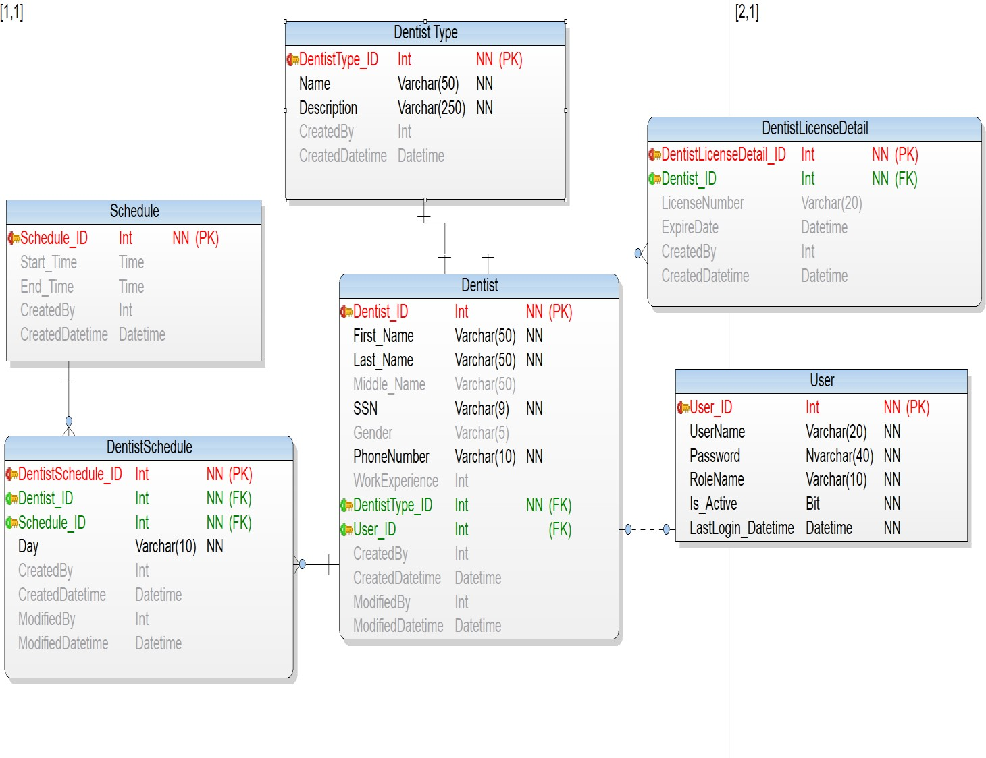

**Inventory Cluster**

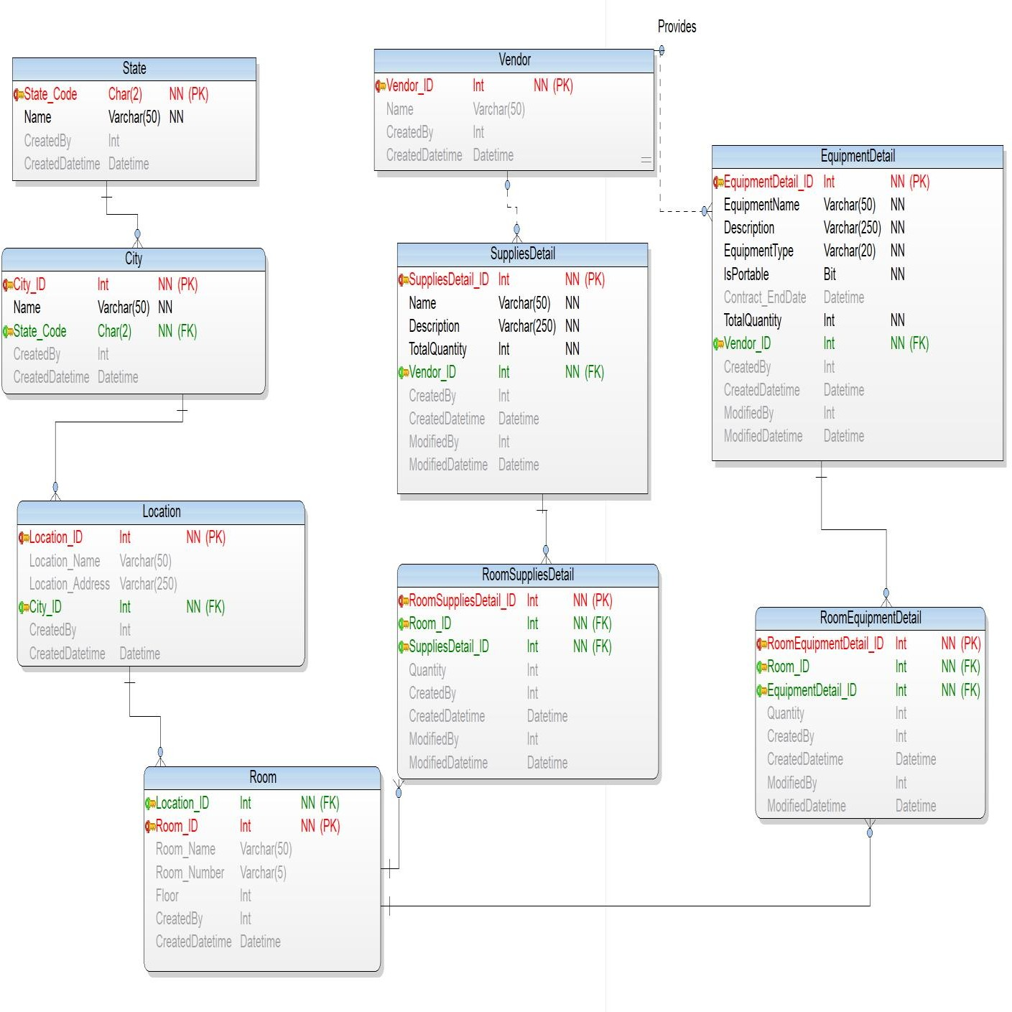

**Patient Cluster**

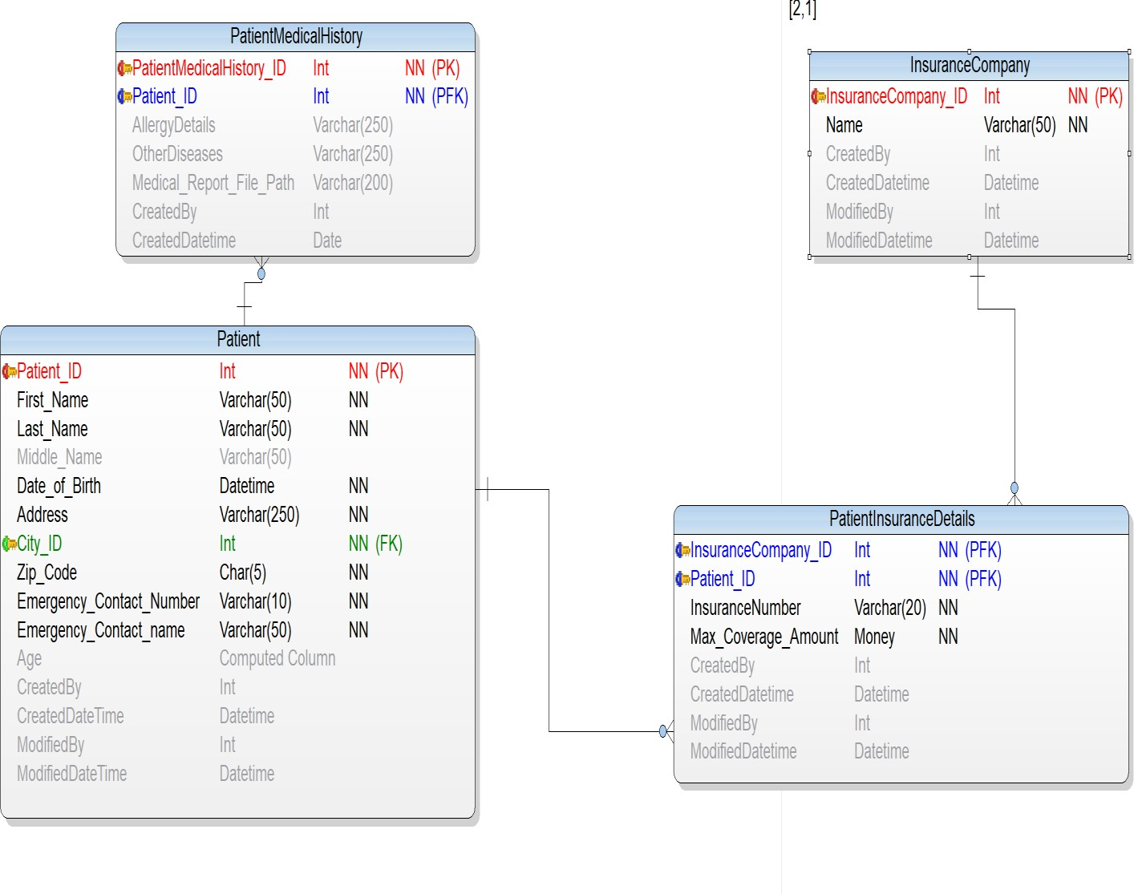

**Treatment Cluster**

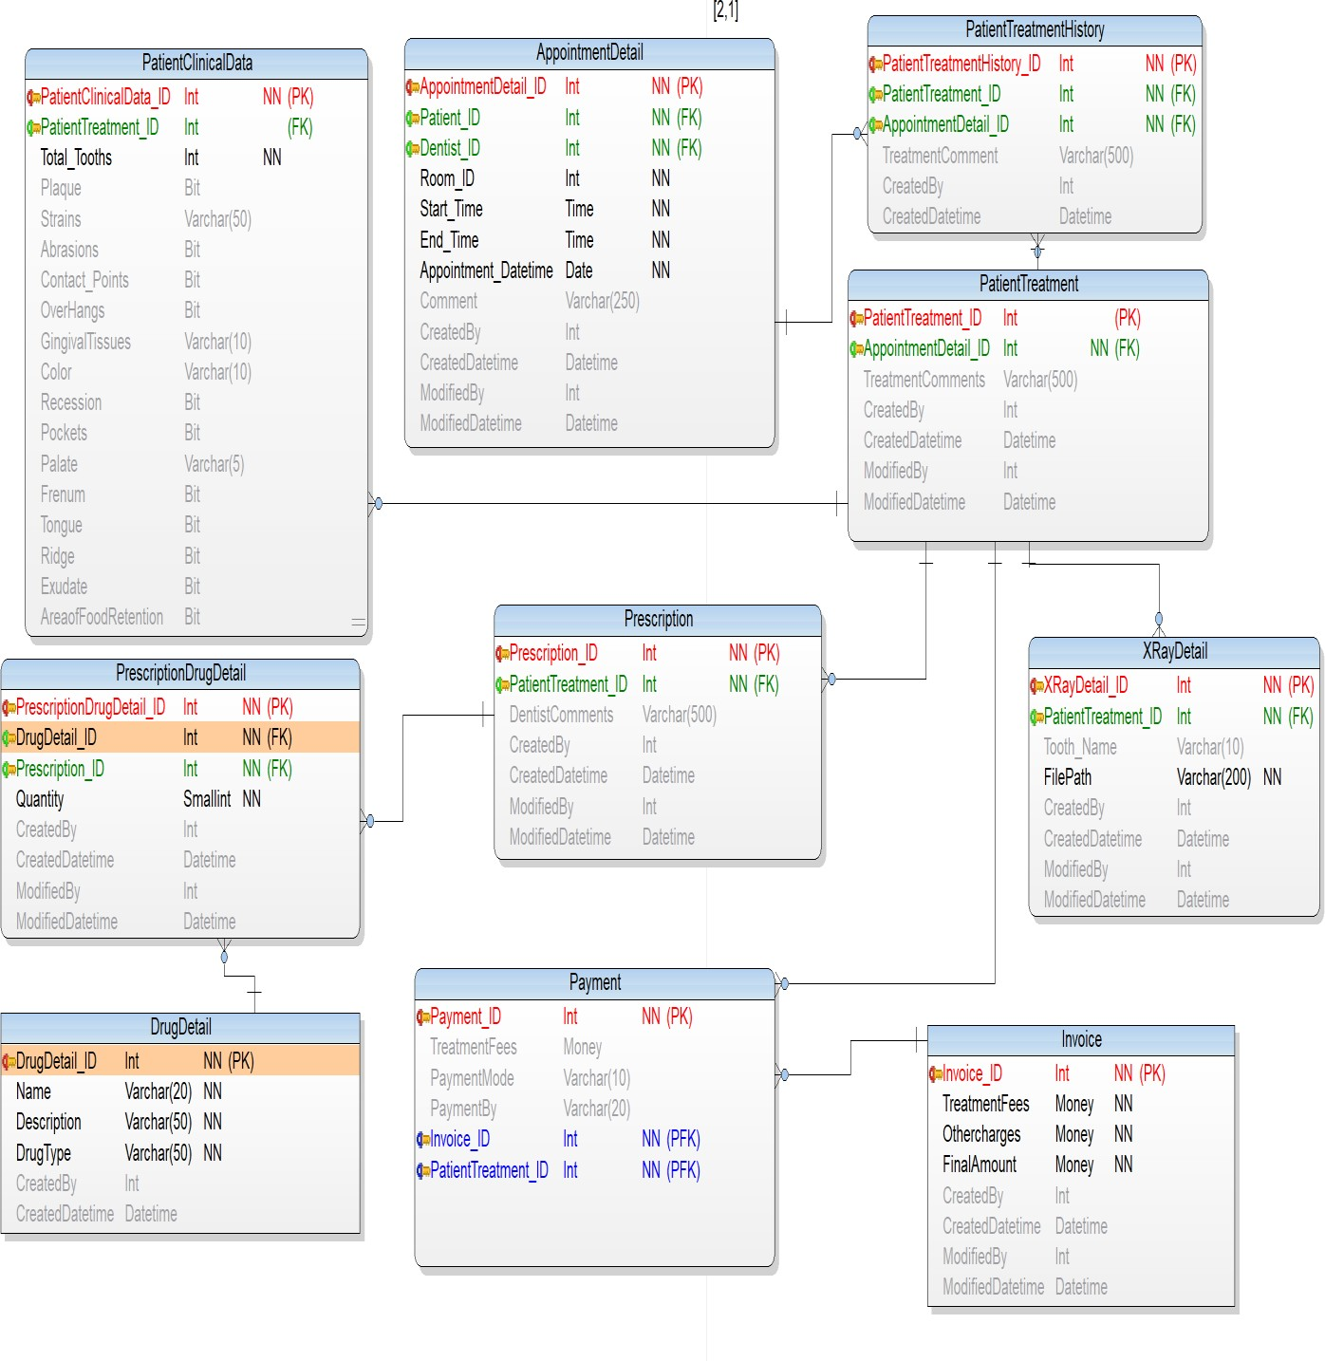

# 8.0 Definition and Abbreviation

PK : Primary Key FK : Foreign Key NN : Not Null

PFK : Primary Foreign Key N : Null